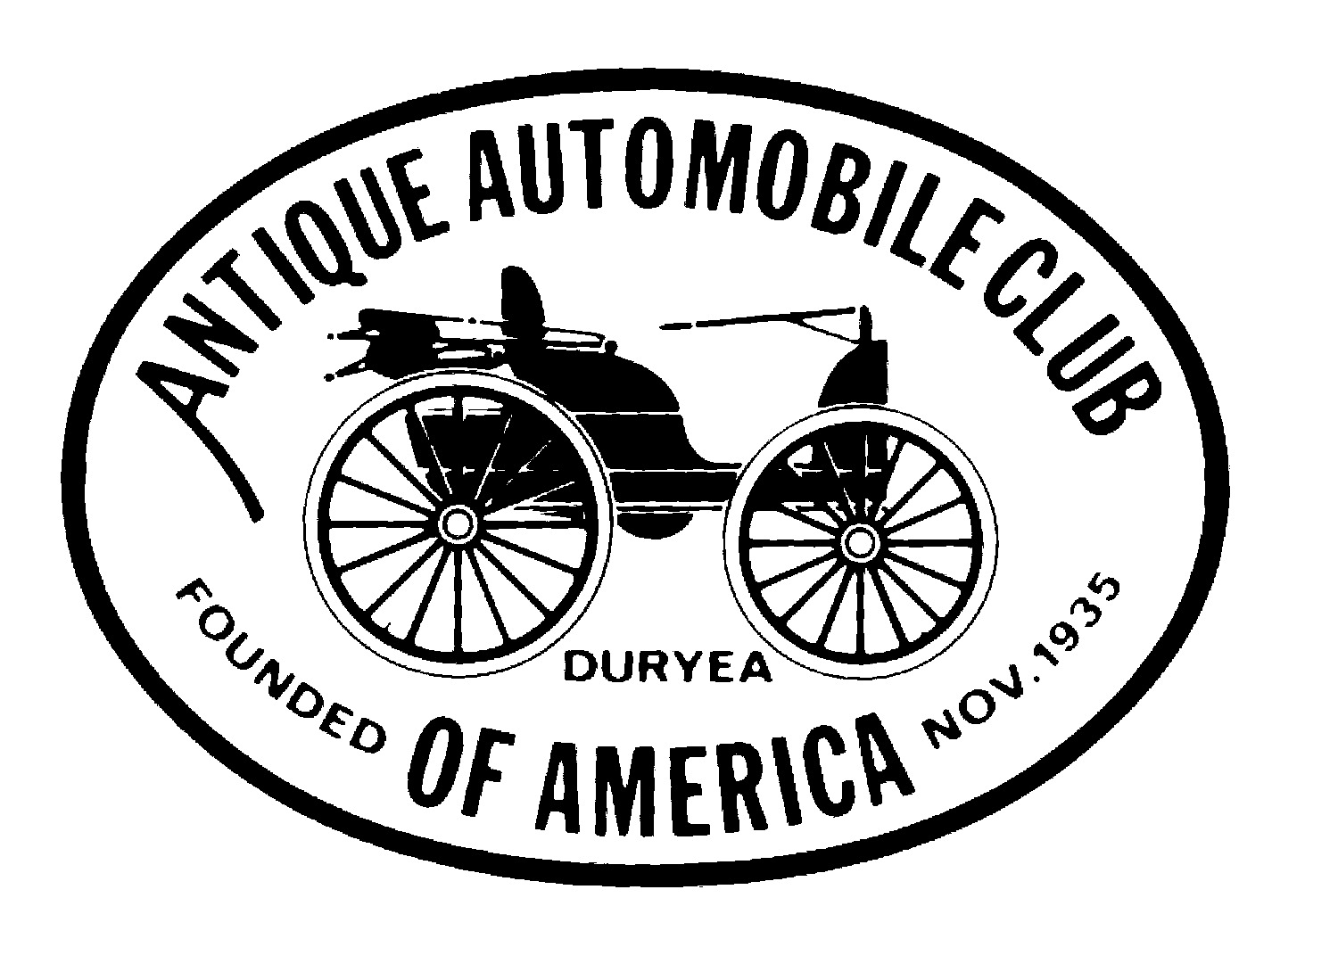
POTTSTOWN REGION AACA CLUB, INC.
2024 APPLICATION FORM

AACA number __________________________ Date ______________________________
Member Name (please print) |  | Joint Name (please print)
Birthday (mm/dd) |  | Birthday (mm/dd)
Address |  | Telephone
City, State, Zip |  | Email address

Car Information
Make | Year | Body Type | Condition

Membership

National AACA Membership is required before acceptance as a Pottstown Region AACA member. Please have AACA # available for new membership.
Membership cost - Currently, Pottstown Region AACA membership is free for 2024.
Mail completed form to: Patricia Strunk, Membership Chairperson, 720 E 8th St. Boyertown, PA 19512.
You can also email completed form to: P1125B@GMAIL.com

MEMBERSHIP PRIVILEGES-https//pottstown.aaca.com

NEWSLETTER FREE CLASSIFIED ADVERTISING FAMILY FUN AND FRIENDSHIP MONTHLY CLUB MEETINGS & ENTERTAINMENT SUMMER PICNIC CHRISTMAS PARTY FACEBOOK

